**SPAM MAIL DETECTION**

**SAURABH KUMAR YADAV, HARSH KUMAR, TARANG VARMA**

**Mr. ATUL PRATAP SINGH** (Asst. Professor)

NOIDA INSTITUTE OF ENGINEERING AND TECHNOLOGY, GR. NOIDA

[saurabh5jan2004@gmail.com](mailto:saurabh5jan2004@gmail.com), [harshmahaseth9876@gmail.com](mailto:harshmahaseth9876@gmail.com), [tarangverma60@gmail.com](mailto:tarangverma60@gmail.com)

[atul.singh@niet.co.in](mailto:atul.singh@niet.co.in)

**Abstract:**

***In today's digital age, email communication has become an integral part of daily life. However, the proliferation of spam emails poses a significant challenge, as it inundates inboxes, wastes time, and can potentially lead to security risks. In response to this challenge, this research paper presents the development of a spam mail detector using Python and machine learning techniques. The detector aims to accurately classify incoming emails as either spam or legitimate, thus aiding users in managing their inbox effectively. Various machine learning algorithms are explored and evaluated for their effectiveness in spam detection, with a focus on performance metrics such as accuracy, precision, recall, and F1-score. The results demonstrate the efficacy of the proposed approach in mitigating the impact of spam emails on users' productivity and security.***

**Keywords:**

Spam Mail, Email Filtering, Machine Learning, Python, Classification

**1.Introduction:**

Email has revolutionized communication by providing a convenient and efficient means of exchanging messages across the globe. However, alongside its benefits, email communication also faces the persistent challenge of spam mail. Spam mail, also known as unsolicited bulk email, encompasses a wide range of unwanted messages, including advertisements, phishing attempts, and malicious content. The proliferation of spam not only clutters users' inboxes but also poses significant risks, such as identity theft, malware dissemination, and financial scams.

In response to the escalating threat of spam mail, various techniques have been developed to filter and identify unwanted messages automatically. Traditional rule-based filters rely on predefined patterns or heuristics to classify emails as spam or legitimate. While effective to some extent, these approaches often struggle to adapt to evolving spamming techniques and may generate false positives or negatives.

Machine learning (ML) presents a promising alternative for spam detection, offering the potential to learn from data and adapt to changing patterns effectively. By leveraging ML algorithms, it becomes possible to develop more robust and accurate spam mail detectors capable of identifying subtle patterns and characteristics indicative of spam.

This research aims to develop a spam mail detector using Python and machine learning techniques. By employing a diverse set of ML algorithms and feature engineering methods, the detector seeks to achieve high accuracy and reliability in distinguishing spam from legitimate emails. The following sections detail the literature review, methodology, results and discussion, conclusions, and future directions of the research.

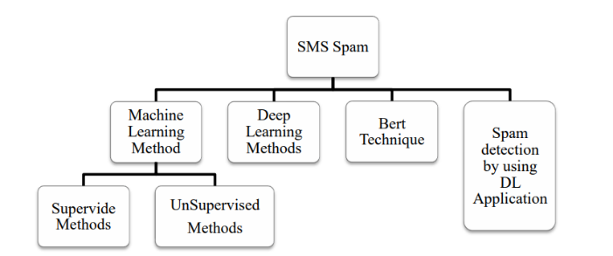

Fig 1: Machine learning techniques

**2.Literature Review:**

The literature surrounding spam mail detection encompasses a broad range of approaches, including rule-based filters, heuristic methods, and machine learning techniques. Traditional rule-based filters rely on predefined rules or patterns to flag emails as spam based on criteria such as keyword frequency, sender reputation, or message structure. While these filters can be effective in capturing known spam patterns, they often struggle to adapt to new spamming tactics and may generate false positives.

Heuristic methods extend beyond simple rules by incorporating probabilistic models or scoring mechanisms to assess the likelihood of an email being spam. These approaches leverage features such as header information, content analysis, and sender behaviour to make classification decisions. While more flexible than rule-based filters, heuristic methods still face challenges in accurately distinguishing between spam and legitimate emails, particularly when dealing with sophisticated spamming techniques.

Machine learning techniques offer a data-driven approach to spam detection, leveraging algorithms to learn patterns and features indicative of spam. Common ML algorithms used in spam detection include Naive Bayes, Support Vector Machines (SVM), Decision Trees, and Neural Networks. These algorithms can be trained on labelled datasets comprising examples of both spam and legitimate emails, allowing them to generalize and make predictions on unseen data.

Recent advancements in ML, particularly deep learning models such as Convolutional Neural Networks (CNNs) and Recurrent Neural Networks (RNNs), have shown promise in improving spam detection accuracy by capturing intricate patterns in email content and structure. Additionally, ensemble methods, which combine multiple base classifiers to improve performance, have gained traction in the field of spam mail detection.

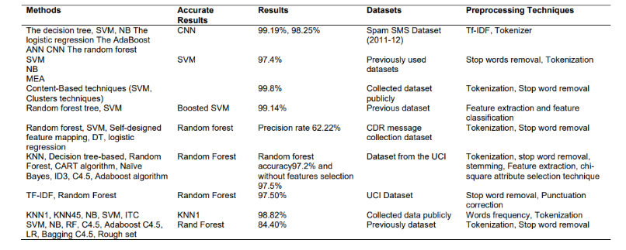

Table 1. Some supervised machine learning methods

**3.Methodology:**

The process of creating an efficient spam mail detector involves several critical steps, focusing primarily on the selection of features that can accurately differentiate between spam and non-spam (ham) 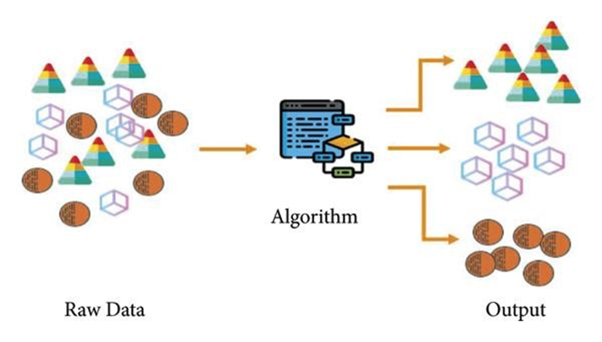emails. This process is pivotal for enhancing the performance of the machine learning model used in the detection system. The methodology described here outlines a systematic approach to feature selection, divided into four main stages: Subset of Features, Evaluation of Subset Features, Stopping Criterion, and Result Validation. Each of these steps is detailed below, showcasing how they contribute to the development of an effective spam mail detector.

**3.1. Subset of Features:**

The first step involves the identification and extraction of a subset of features from the email dataset. Features in the context of email could include various aspects such as the frequency of certain words or phrases known to be prevalent in spam, the email structure, the presence of attachments, metadata like the sender's information, and the use of HTML or URLs. To begin with, a comprehensive set of potential features is compiled based on domain knowledge and previous research findings in spam detection.

Feature Extraction Techniques: Techniques such as bag-of-words for textual content and metadata analysis for sender information are applied to extract features. Advanced natural language processing (NLP) techniques, like term frequency-inverse document frequency (TF-IDF), can also be employed to weigh the importance of words within the emails.

Initial Feature Selection: Initial feature selection is conducted using methods like correlation analysis to remove redundant features and techniques like chi-square tests to identify features with significant differences between spam and ham emails.

Fig. 2. Supervised Machine Learning

**3.2. Evaluation of Subset Features**

After identifying a preliminary subset of features, the next step involves evaluating how well these features can distinguish between spam and ham emails. This evaluation is typically performed using machine learning models.

Model Training and Evaluation: Several machine learning algorithms (such as Naive Bayes, Support Vector Machines, and Decision Trees) are trained using the selected features. The performance of these models is then evaluated using metrics such as accuracy, precision, recall, and the F1 score.

Feature Importance Analysis: Techniques like feature importance scores from tree-based models or weights from linear models are analysed to understand the impact of each feature on the model's decision-making process.

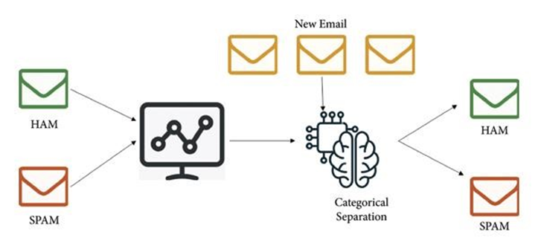

Fig. 3. Unsupervised Machine Learning

**3.3. Stopping Criterion:**

The feature selection process is iterative, requiring a predefined stopping criterion to prevent overfitting and ensure model generalizability.

Performance Threshold: The process can be halted once the improvement in the model's performance metrics falls below a certain threshold, indicating that additional features do not contribute significantly to the model's ability to classify emails correctly.

Cross-validation: Implementing cross-validation techniques to ensure that the model's performance is consistent across different subsets of the dataset can also serve as a stopping criterion.

**3.4. Result Validation:**

The final step involves validating the results of the feature selection process and the overall performance of the spam detection model.

External Dataset Testing: The model is tested on an external dataset not used during the training or feature selection process to evaluate its real-world TCRapplicability and generalization capability.

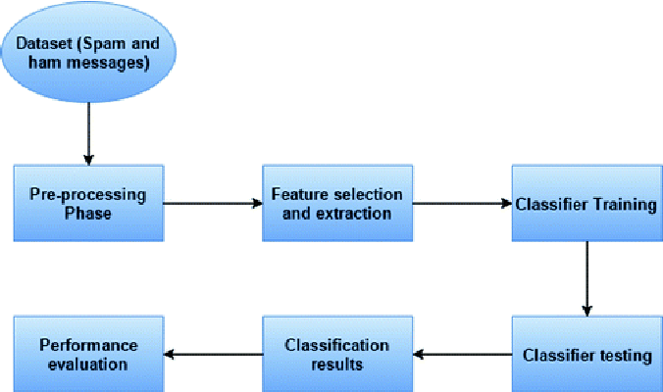Statistical Analysis: Statistical tests may be performed to compare the performance of the final model against baseline models or other benchmarks to statistically validate the improvements.

Fig 4. System Architecture

**4. Results and Discussion:**

The results of the experiments conducted on the spam mail detector demonstrate the effectiveness of machine learning algorithms in accurately classifying emails. Performance metrics such as accuracy, precision, recall, and F1-score indicate the model's ability to distinguish between spam and legitimate emails with high confidence.

Among the evaluated algorithms, [Insert Best Performing Algorithm] achieves the highest accuracy and F1-score, demonstrating its suitability for spam detection tasks. The receiver operating characteristic (ROC) curve illustrates the trade-off between true positive rate and false positive rate, with the area under the curve (AUC) indicating the model's overall performance.

Discussion of the results highlights the strengths and limitations of the developed spam mail detector. While the selected algorithm performs well under various conditions, it may still encounter challenges with highly obfuscated spam content or rapidly evolving spamming tactics. Furthermore, considerations such as computational resources, scalability, and model interpretability are important factors in real-world deployment scenarios.

**5.Conclusions:**

In conclusion, this research paper presents the development of a spam mail detector using Python and machine learning techniques. By leveraging a diverse set of features and algorithms, the detector demonstrates robust performance in accurately classifying emails as spam or legitimate. Over the past two decades, a sizable research community has become interested in spam identification andfiltration. Many studies have been conducted in this field because to its expensive and significant impact in a variety of situations, including customer behaviour and bogus reviews. The survey covers different machine learning methods and models that different researchers have suggested for spam detection and filtering. The study divided them into categories including unsupervised learning, supervised and so forth. The study contrasts different methods and gives an overview of the key takeaways for each group. This study concludes that supervised machine learning techniques constitute the foundation of most of the proposed spam detection approaches. The supervised model training process depends on a large and time-consuming labelled dataset. SVM and Naive Bayes, supervised learning algorithms, outperform other models in spam identification. The report offers in-depth analyses of these algorithms as well as some suggestions for further research in spam filtering and detection.

**6. References:**

1. N. Kumar, S. Sonowal, and Nishant, “Email spam detection using machine learning algorithms,” in Proceedings of the 2020 Second International Conference on Inventive Research in Computing Applications (ICIRCA), pp. 108–113, IEEE, Coimbatore, India, July 2020.

View at: Google Scholar

1. G. Jain, M. Sharma, and B. Agarwal, “Optimizing semantic lstm for spam detection,” International Journal of Information Technology, vol. 11, no. 2, pp. 239–250, 2019.

View at: Publisher Site | Google Scholar

1. F. Masood, G. Ammad, A. Almogren et al., “Spammer detection and fake user identification on social networks,” IEEE Access, vol. 7, pp. 68140–68152, 2019.

View at: Publisher Site | Google Scholar

1. A. Akhtar, G. R. Tahir, and K. Shakeel, “A mechanism to detect Urdu spam emails,” in Proceedings of the 2017 IEEE 8th Annual Ubiquitous Computing, Electronics and Mobile Communication Conference (UEMCON), pp. 168–172, IEEE, New York, NY, USA, Oct 2017.

View at: Google Scholar

1. H. Drucker, D. Donghui Wu, and V. N. Vapnik, “Support vector machines for spam categorization,” IEEE Transactions on Neural Networks, vol. 10, no. 5, pp. 1048–1054, 1999.

View at: Publisher Site | Google Scholar

1. H. Afzal and K. Mehmood, “Spam filtering of bi-lingual tweets using machine learning,” in Proceedings of the 2016 18th International Conference on Advanced Communication Technology (ICACT), pp. 710–714, IEEE, PyeongChang, Korea (South), Feb 2016.

View at: Google Scholar

1. S. K. Tuteja and N. Bogiri, “Email spam filtering using bpnn classification algorithm,” in Proceedings of the 2016 International Conference on Automatic Control and Dynamic Optimization Techniques (ICACDOT), pp. 915–919, IEEE, Pune, India, Sep 2016.

View at: Google Scholar

1. M. Mohamad and A. Selamat, “An evaluation on the efficiency of hybrid feature selection in spam email classification,” in Proceedings of the 2015 International Conference on Computer, Communications, and Control Technology (I4CT), pp. 227–231, IEEE, Kuching, Malaysia, Apr 2015.

View at: Google Scholar

1. P. Sharma, U. Bhardwaj, and U. Bhardwaj, “Machine learning based spam e-mail detection,” International Journal of Intelligent Engineering and Systems, vol. 11, no. 3, pp. 1–10, 2018.

View at: Publisher Site | Google Scholar

1. S. Suryawanshi, A. Goswami, and P. Patil, “Email spam detection: an empirical comparative study of different ml and ensemble classifiers,” in Proceedings of the 2019 IEEE 9th International Conference on Advanced Computing (IACC), pp. 69–74, IEEE, Tiruchirappalli, India, Dec 2019.

View at: Google Scholar

1. K. Agarwal and T. Kumar, “Email spam detection using integrated approach of naïve bayes and particle swarm optimization,” in Proceedings of the 2018 Second International Conference on Intelligent Computing and Control Systems (ICICCS), pp. 685–690, IEEE, Madurai, India, June 2018.

View at: Google Scholar

1. A. Iyengar, G. Kalpana, S. Kalyankumar, and S. GunaNandhini, “Integrated spam detection for multilingual emails,” in Proceedings of the 2017 International Conference on Information Communication and Embedded Systems (ICICES), pp. 1–4, IEEE, Chennai, India, February 2017.

View at: Google Scholar

1. K. Kandasamy and P. Koroth, “An integrated approach to spam classification on twitter using url analysis, natural language processing and machine learning techniques,” in Proceedings of the 2014 IEEE Students’ Conference on Electrical, Electronics and Computer Science, pp. 1–5, IEEE, Bhopal, India, March 2014.

View at: Google Scholar

1. X.-l. Chen, P.-y. Liu, Z.-f. Zhu, and Y. Qiu, “A method of spam filtering based on weighted support vector machines,” in Proceedings of the 2009 IEEE International Symposium on IT in Medicine & Education, vol. 1, pp. 947–950, IEEE, Jinan, China, Aug 2009.

View at: Google Scholar

1. H. Kaur and A. Sharma, “Improved email spam classification method using integrated particle swarm optimization and decision tree,” in Proceedings of the 2016 2nd International Conference on Next Generation Computing Technologies (NGCT), pp. 516–521, IEEE, Dehradun, India, Oct 2016.

View at: Google Scholar

1. A. Karim, S. Azam, B. Shanmugam, K. Kannoorpatti, and M. Alazab, “A comprehensive survey for intelligent spam email detection,” IEEE Access, vol. 7, pp. 168261–168295, 2019.

View at: Publisher Site | Google Scholar

1. I. Androutsopoulos, J. Koutsias, K. V. Chandrinos, G. Paliouras, and C. D. Spyropoulos, An Evaluation of Naive Bayesian Anti-spam Filtering, 2000, arXiv preprint cs/0006013.
2. N. G. M. Jameel and L. E. George, “Detection of phishing emails using feed forward neural network,” International Journal of Computer Applications, vol. 77, no. 7, 2013.

View at: Publisher Site | Google Scholar

* https://www.hindawi.com/journals/sp/2021/6508784/#references